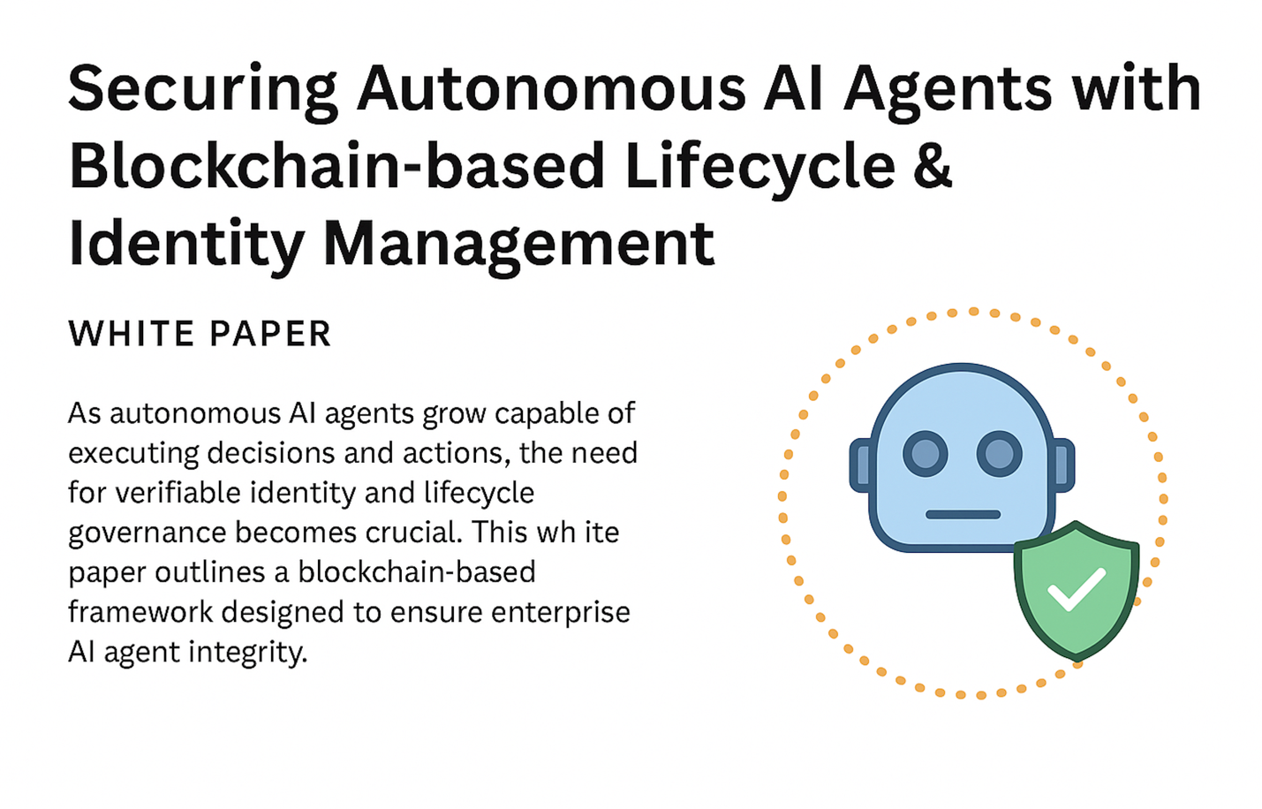

Executive Summary
As enterprises increasingly adopt autonomous AI systems to augment or replace human tasks, the challenge of securing these non-human agents has emerged as a critical gap. Traditional identity systems were never designed to manage or monitor autonomous AI entities that operate independently, evolve continuously, and interact with sensitive systems. nxtlinq, through its patent-backed framework, addresses this challenge by introducing a blockchain-based lifecycle and identity management system for AI agents. This framework ensures each agent's authenticity, behavior traceability, delegation authority, and operational accountability throughout its existence.

Introduction
Autonomous AI agents are transforming how decisions are made, how operations are executed, and how value is created across industries. From algorithmic trading bots and healthcare diagnostic engines to customer service automation and infrastructure monitoring, these agents increasingly function with minimal or no human oversight. As these capabilities expand, so too does the need for a secure and transparent system to govern the identity, behavior, and lifecycle of each agent.
Today’s identity and access management (IAM) platforms lack the granularity and architecture to handle agent autonomy, agent-to-agent communication, or cryptographic delegation. Additionally, AI agents can be copied, modified, or maliciously deployed without existing systems detecting anomalies. nxtlinq’s proposed architecture overcomes these limitations by tokenizing the identity of each AI agent (via an AI Identity Token or AIT), tracking its lifecycle, enforcing behavioral constraints, and integrating human delegation (via HIT - Human Identity Token) where applicable.

Problem Space
1. Unverifiable Agent Identity
Current systems have no way to reliably prove the origin or state of an AI agent once deployed. This opens the door to impersonation, misuse, or deployment of rogue agents.
2. Lack of Lifecycle Management
Most AI agents operate without any lifecycle tracking. Updates, delegations, or ownership transfers go unrecorded, making accountability and rollback impossible.
3. No Behavioral Oversight
Autonomous agents can gradually drift from original behavior through retraining, unauthorized logic changes, or context manipulation.
4. Absent Delegation Framework
Human-to-AI or AI-to-AI delegation isn’t standardized, leaving enterprises without an auditable chain of command when AI agents act on behalf of users or other agents.
5. Compliance Exposure
Without identity and action traceability, enterprises deploying AI agents expose themselves to regulatory risk, particularly in finance, healthcare, and critical infrastructure.

nxtlinq's AIT Framework: Key Components
1. AI Identity Token (AIT)
A cryptographically generated and blockchain-anchored identity token assigned to each AI agent. It encapsulates:
- Unique agent fingerprint (binary hash, model signature)
- Role and permission set
- Delegation chain metadata
- Smart contract-bound behavioral policies
2. Blockchain Ledger
Serves as the immutable record for:
- Agent creation, state changes, and deprecation
- Delegation issuance and revocation
- Behavioral logs, trust scores, and event triggers
3. Delegation Protocol
Human Identity Tokens (HITs) link human actors to AI agents they control or authorize. Delegation policies are codified in smart contracts and automatically enforceable.
4. Trust Scoring Engine
AI agents are continuously evaluated based on:
- Behavioral integrity (did the agent follow policy?)
- Contextual appropriateness (was its decision within scope?)
- Interaction audit logs
5. Revocation and Re-authentication
Upon anomaly detection, an AIT can be revoked. The agent is isolated until its identity, integrity, and authorization are re-validated.

Lifecycle Flow
- Registration → An agent is instantiated and fingerprinted; AIT is issued.
- Delegation → Human owner assigns authority using HIT; scope defined.
- Permission Provisioning → Roles, scopes, and boundaries are configured based on enterprise policy.
- Activation → Agent interacts with systems and other agents; all activity logged.
- Monitoring → Smart contracts enforce role limits and track behaviors.
- Revocation → If thresholds are violated, AIT is paused or revoked.
- Re-certification → Agent can be reissued a new AIT upon revalidation.

Use Cases
1. Financial Trading Bots
Ensure trading AI agents are operating under valid licenses and authorization from registered humans or institutions. Block rogue agents.
2. Healthcare Diagnostic Systems
AI recommending treatments must be verifiably linked to licensed providers and operate within approved decision boundaries.
3. Smart Contract Executors
Agents that trigger blockchain-based transactions can be validated through AITs before execution.
4. AI-Powered Security Gateways
Identify and authenticate AI systems managing access control, ensuring agents cannot impersonate or exceed authority.
5. Industrial Automation Agents
Protect and monitor AI-driven robotic agents in manufacturing or energy sectors through full lifecycle tracking.

Strategic Benefits
- Zero Trust Architecture for AI: Treat every agent as untrusted until continuously verified.
- Cross-Enterprise Operability: Agents can carry verified AITs across ecosystems, preserving identity and trust.
- Regulatory Readiness: Demonstrates responsible AI practices through transparent logs and enforcement.
- Interoperable Identity System: HIT and AIT systems create a unified identity layer for both humans and machines.

Integration with Existing IAM Providers
nxtlinq's HIT and AIT framework can be integrated with leading identity and access management platforms (IAM) such as Okta, Ping Identity, ForgeRock, and Microsoft Entra. Integration can be achieved via:
- Federated identity bridging between HITs and existing SSO identities
- Policy orchestration and enforcement via SCIM, SAML, or OIDC extensions
- Embedding of AIT validation as a conditional check within IAM workflows
Through these integrations, existing enterprise IAM systems can delegate agent control, enforce permissions, and consume blockchain-verified identity data to strengthen security.

Example Implementation Scenario
Scenario: Financial Institution with Trading AI Agents
- Human trader logs in via Okta (HIT mapped)
- Delegates authority to AI agent with time-limited scope
- IAM integrates with nxtlinq to record and monitor the delegation and assign an AIT
- AI agent executes trades within authorized scope; logs fed back to IAM and ledger
- Anomaly triggers revocation and session isolation in real time
This integration preserves current IAM investments while expanding identity governance to include non-human actors.

Conclusion
As AI becomes more agentic and decentralized, the infrastructure that governs its identity and accountability must evolve in parallel. nxtlinq’s blockchain-based AI agent lifecycle and identity management framework establishes a scalable, secure, and standards-aligned foundation for the next era of intelligent automation. With verifiable tokens, behavioral oversight, and immutable audit trails, enterprises can deploy AI agents confidently, knowing every action is accountable, traceable, and policy-compliant.
